Games behind the scenes

Does gaming cause anxiety? How does this happen and what is the reason behind that?  
  
Team #1 | Ahmad Alkofahi, Ayman Attili, Rania Rifai, Silina Alkhatib, Moutaz Mazaida

____________________________________________________________________________

# **Introduction**

There are currently 3.24 billion gamers worldwide, a number that has been rising over the past few years. These players run the risk of becoming addicted to gaming, with a constant need to play video games. This is because studies have shown that the same brain regions that are activated in craving in drug and alcohol addicts are also activated in video game addicts when they see images of video games(1). As a result, addicted gamers frequently experience mental health problems that have an impact on several facets of their lives. For instance, students who are gaming addicts tend to perform worse academically than their friends who are not.(2)

Anxiety is one of the significant diseases and mental health difficulties connected to addiction, but can anxiety be brought on by gaming? Are they connected, too?

# **Business Impact**

There is a growing concern worldwide about the potential of negative mental health consequences associated with playing video games. Studies have shown that people diagnosed with Internet gaming disorder are more likely to be aggressive, depressed, and anxious. The main mechanism that leads to those comorbidities is their inability to regulate and control their emotions, such as anger, sadness, fear, or other emotions, affecting their lifestyle.

This analysis's goal is to examine the relationship, level and impact of anxiety disorders such as generalized anxiety disorder (GAD) and social anxiety disorder (Social Phobia-SPIN) on gamers' lives and their levels of life satisfaction too. While categorizing games based on two attributes, first time based on their current work status and second time based on their educational level.

# **Data**

## **Dataset Details:**

We have used one dataset for this project, this dataset consists of data collected as a part of a survey among gamers worldwide. The questionnaire included questions that psychologists generally ask to people who are prone to GAD, SPIN, SWL, and a few other questions related to gamers personal information and gaming lifestyle.

## **Data Structuring:**

We have divided the dataset into 5 categories (GAD, SPIN, SWL, Play Style and Personal Information)

## **Data Cleaning:**

We have performed the following:

1. For (Hours per Week) column, which represents that total number of hours played by gamers, per week:
2. We have removed the rows of data that contains non logic values such as (420 and 8000) since the week consists of 168 hours
3. We have removed the rows of data that contains (NA) values

B) For (Streams per Week) column, which represents that total number of hour streamed by gamers, per week,

1. We have removed the rows of data that contains non logic values such as (200) since the week consists of 168 hours
2. We have removed the rows of data that contains (NA) values

C) For the tests results, the answers should be ranked either from (0-3, 1-4, 1-7):

1. We have used the Max and Min functions to make sure that the that values are within these ranges
2. We have removed the rows of data that contains (NA) values

D) For Age:

1. We have used the Max and Min functions to make sure that the that values are within the logical range
2. We did not find any rows with (NA) values

E) For Work:

1. We have removed the rows of data that contains (NA) values

F) For Gender:

1 .We did not focus on gender during our analysis since males were dominant (around 94% of the Respondents were males)

We have also removed the unnecessary columns like Birthplace_ISO, Residence_ISO, Reference, accept, League and highest league.

* Total number of rows before data cleaning:13,464
* Total number of rows after data cleaning:12,668

# 

# **Data Analysis & Computation**

Through our analysis we wanted to focus on the test results of the GAD, SPIN and SWL, however, since every test in our dataset was composed of many questions and each question had a score result, we have decided to sum the results for each test, into a new column. Therefore, we have created three new columns: (Sum GAD, Sum SPIN, Sum SWL) using the sum function.

## Gamers and Working Status

Our dataset categorizes the gamers working status to the following:

* Employed
* Unemployed/Between Jobs
* Student at College/University
* Student at School

The work status represents the current gamer working status (at the time of filling the survey).

We have started our analysis by comparing gamers' life satisfaction based on their work status.

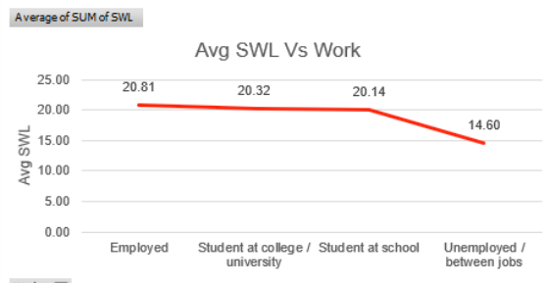

Figure 1. Average Satisfaction with life (SWL) vs Work status

From Figure 1, Unemployed gamers have scored the lowest SWL test results, which means they are the least satisfied category with their lives.

Since, Unemployed gamers are the least satisfied category, we wanted to check the relation between work status and Average hours played/streamed through the week

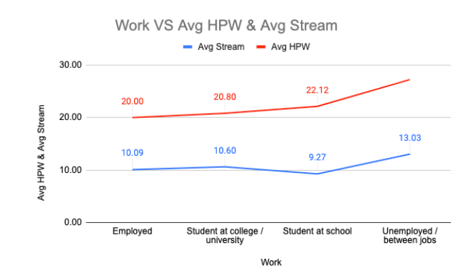

Figure 2. Average Hours played per week (HPW) and Average Stream vs Work status

From figure 2, Unemployed gamers spend the highest number of hours on gaming regardless of whether they are playing or streaming, which can also lead to why they are not satisfied with their lives, they avoid their actual lives by spending much time on gaming.

We also wanted to see how age is related to Average hours played/stream per week.

.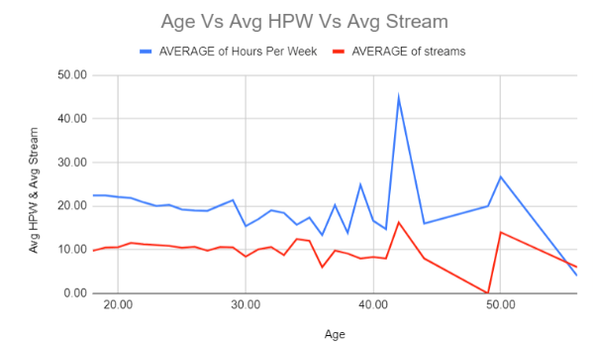

Figure 3. Age vs Average Hours played per week (HPW) and Average Stream

From Figure 3, we conclude that gamers between (41-42) years, play/stream the highest hours during the week.

Then, we wanted to see how GAD and SPIN are related to average hours played per week and over age.

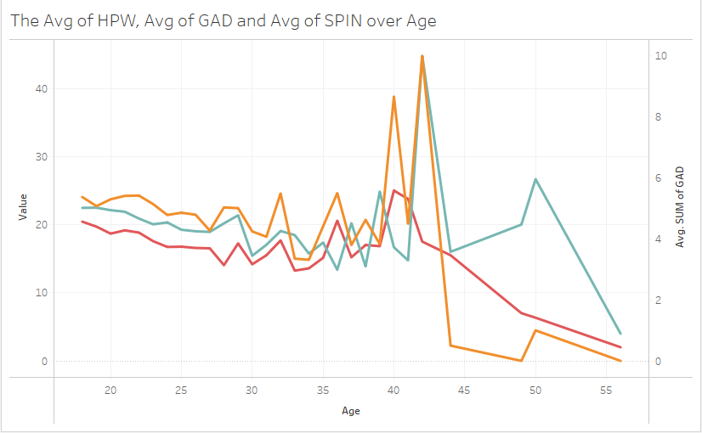

Figure 4. Average hours played per week (Green line) vs Average sum of GAD Test results (Orange line) vs Average sum of SPIN Test results (Red line) over the age

From figure 4, Gamers between age 41 and 42 as concluded earlier, have scored the highest Average of hours played per week, and the they have the highest GAD test result, they are more eligible for GAD compared to others, while for SPIN, gamers at age 40 scored the highest value.

Finally, we wanted to sum up all the relations between GAD, SPIN, Hours played per week and streams and define which work category needs the most attention.

# 

Figure 5: Average sum of GAD Test Results, Average sum of SPIN Test results, Average hours played per week, Average hours streamed per week, vs Work status

From Figure 5, we conclude the following:

* Unemployed gamers scored the highest GAD, highest SPIN, highest Hours played and highest stream.
* The higher the number of hours played, the higher GAD Test Results and Higher SPIN Test results.

## **Gamers and Working Status Datafolio**

Below is the datafolio we have created, showing the graphs and highlights related to Gamers and Working status. ([by clicking here for external picture link](https://www.canva.com/design/DAFTc7_L9bY/JMsPZAKBLYjcZQXZiplzgQ/view?utm_content=DAFTc7_L9bY&utm_campaign=designshare&utm_medium=link2&utm_source=sharebutton))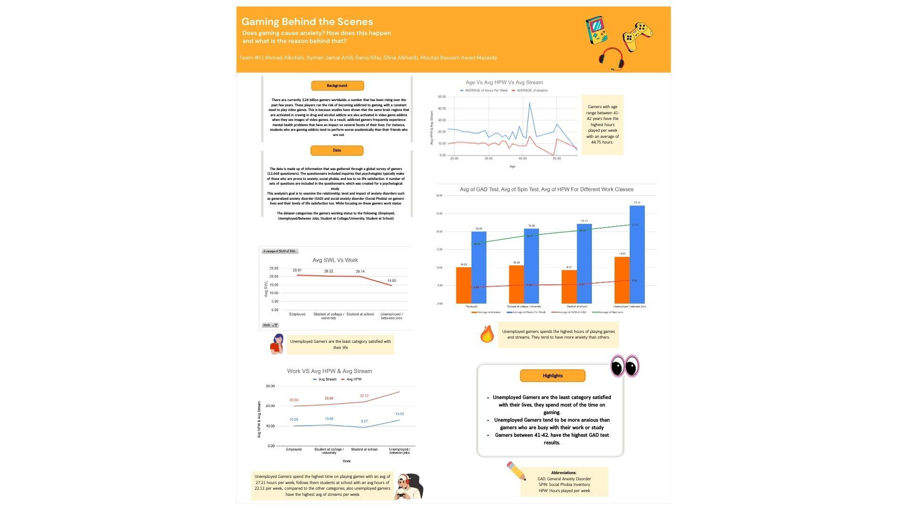

Figure 6:Gaming Behind the Scenes Datafolio

## **Gamers and Educational Degree**

We also wanted to perform some analysis based on the gamers educational degree.

Our dataset categorizes the gamers educational degree to the following categories:

* High school diploma (or equivalent)
* Bachelor (or equivalent)
* Master (or equivalent)
* PH.D., Psy. D., MD (or equivalent)
* None

For gamers under the category (None), we have used the (Max and Min) to define the age range for this category, it ranges between (18-50) therefore we have concluded that gamers under this category have left school earlier and have no educational degree since the minimum age value was 18.

The work status represents the current gamer working status (at the time of filling the survey)

We wanted to see how the educational level is related to the average hours played/streamed per week.

# 

Figure 7: Average hours played per week (green bar chart) and average of streams (red line chart) vs educational level

From figure 7, we can conclude that gamers with high school or gamers without education degrees (None) are the most popular categories that spend time on gaming.

Based on the previous analysis through this report, since gamers who spend the most time in gaming, should be the least category satisfied with their lives, therefore, gamers with high school diploma and gamers without educational degree (none) should be the least satisfied gamers among all categories

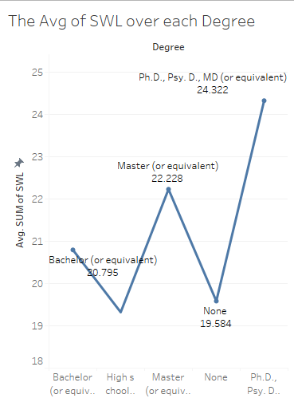

Figure 8: Average of SWL vs educational degree

Figure 8 confirms to us that gamers with high school diplomas and gamers with no educational level (None) scored the lowest values of Satisfaction with life test results, meaning they are the least satisfied of the two categories.

Gamers with high school diplomas and gamers with no educational level (None) should have the highest GAD and SPIN test results.

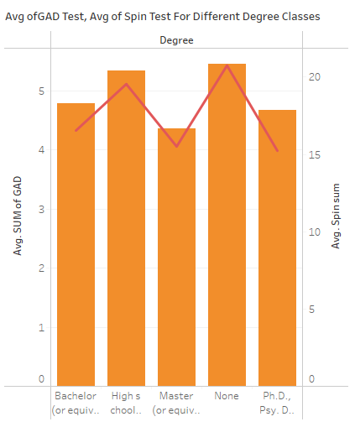

Figure 9: Average of sum of GAD test(orange bar chart), Average of sum SPIN test(red line chart) vs different education degree classes

Figure 9 confirms to us that gamers with high school diplomas and gamers with no educational level are more eligible to have GAD and SPIN than gamers who achieved more educational degrees.

## **Gamers and Educational Degree Dashboard**

We have created an interactive dashboard on Tableau for Gaming Behind the Scenes with focus on gamers based on their education level

Dashboard can be viewed by [Clicking Here](https://public.tableau.com/app/profile/ayman2975/viz/shared/7CXZ6WWMZ)

# 

# Conclusion & Future Work

## **Conclusion**

Through our analyses we have found out that mental health and gaming are related and wrong practices of gaming such as spending too much time on gaming (regardless of just playing or streaming), both can lead to serious mental health issues.

Unemployed gamers have the lowest satisfaction of life score, as they spend much more time on gaming compared to other gamers. They tend to be more anxious than others. Also, gamers between 41-43 have the highest GAD test results.

Gamers with only a school diploma or even without educational degree (none), tend to be more anxious compared to gamers with higher educational levels, since the higher the educational level, the more focus on studying and less focus on gaming.

## **Future work**

We want to create a model that can predict GAD and SPIN severity levels based on age, number of hours played and work status. Then to implement this model in a gaming telemonitoring software, that connects gamers with healthcare institutes in order to provide mental health support at an early stage, spread gaming anxiety awareness and the negative effects of gaming on mental health as well.

Below some of the features in the software:

* The software will monitor the number of hours played/streamed
* Send awareness notifications to gamers
* Block the game if exceeded specific number of hours
* Monthly Anxiety and other possible mental health Related Tests.
* Store gamers data and share it with the healthcare institutes for continue tracking (Full Analysis)

We are also looking to study the relation between gaming and other healthcare problems such as Obesity, Depression, Diabetes, Sleeping disorders and stress, by connecting with other datasets.

# References and Links

* Dataset reference by [Clicking Here](https://www.kaggle.com/datasets/divyansh22/online-gaming-anxiety-data)
* Survey by [Clicking Here](https://osf.io/vyr5f)
* Datafolio Analysis Based on Work Status by [Clicking Here](https://www.canva.com/design/DAFTc7_L9bY/JMsPZAKBLYjcZQXZiplzgQ/view?utm_content=DAFTc7_L9bY&utm_campaign=designshare&utm_medium=link2&utm_source=sharebutton)
* Dashboard Analysis Based on Educational Level by [Clicking Here](https://public.tableau.com/app/profile/ayman2975/viz/shared/7CXZ6WWMZ)
* Reference (1) by [Clicking Here](https://www.researchgate.net/publication/23461082_Brain_activities_associated_with_gaming_urge_of_online_gaming_addiction#:~:text=On%20the%20brain%20level%2C%20brain,%2C%20%2C%202013.%20...&text=...,-Those%20participants%20with)
* Reference (2) by [Clicking Here](http://www.liebertonline.com/doi/abs/10.1089/cpb.2004.7.571?journalCode=cpb)